Some of Our Recipients…

Village Bicycle Project in Ghana

pcei.org/vbp
Bicycles are a basic tool of development, improving access to farms, market, jobs, schools, and health care. Village Bicycle Project receives more than 500 bikes a year from the Working Bikes Co-op. Working Bikes is different from other ‘donors’ in that it donates most of the shipping costs, as well as the bikes. VBP teaches basic maintenance and repair, equipping about 1000 people a year with bikes and training. People say things like, “I never knew that I could repair a puncture myself”.

International Refugee Center, Chicago, IL
heartlandalliance.org
After fleeing persecution in his home country and waiting in a camp for years, Jean was granted legal refugee status in Chicago. After securing employment with a downtown hotel, Jean received a bicycle from Working Bikes Cooperative. He rides his bike everywhere and knows the city as well as any native resident now. Over 60 refugees have received bicycles from Working Bikes, providing these newcomers an affordable way to explore their new city and run daily errands.

MayaPedal in Guatemala
mayapedal.org
Mayapedal is a non-profit in Guatemala devoted to improving the lives of Mayan Indians with "bike machines". These machines include bike-powered coffee huskers, water pumps, blenders, and even washing machines, and can be used where there is no electricity. Working Bikes has donated nearly half of Mayapedal’s total bikes.

Check our website, workingbikes.org, for a complete list of partners.
What is Working Bikes?

You or your organization can donate bicycles to Working Bikes Cooperative. We ship bikes to projects in poorer countries, including: Guatemala, Peru, Ghana, Kenya, Angola, Tanzania, and Cuba. Working Bikes ships over 4000 bikes a year to projects in developing countries and gives away over 500 working bikes a year locally to U.S. recipients.
We were started in 1998 as an all-volunteer organization dedicated to recycling bikes, supporting a bike culture in Chicago, and helping local as well as international projects in need of bikes.
We accept any and all bikes – they do not have to be working! Working Bikes is a 501c3 charitable organization.
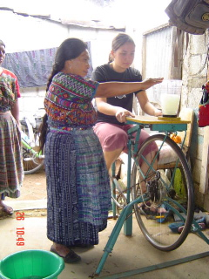
Bike-Blender at Maya Pedal
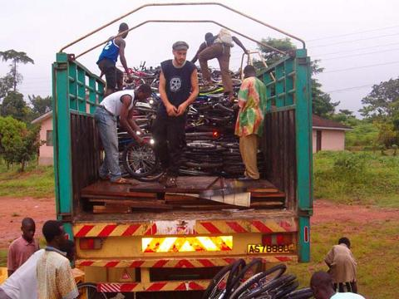
Unloading bikes in Ghana

How Can you help?

- Volunteer with us at 2434 S. Western. It's fun, you get to learn about the project, and you can hone your bike mechanic skills.
- Help us pack a 40 foot container for shipment to an overseas destination. Check our website for specific dates at workingbikes.org
- Donate a bike at one of our drop-off locations, listed below. If you have more than ten bikes we are happy to come pick them up.
- Organize a bike drive in your community.

For more information contact:

donate@workingbikes.org or call (773) 847-5440 to donate bike(s).

educate@workingbikes.org or call (312) 371-4286 for the education department.
volunteer@workingbikes.org or call (773) 220-2006 to volunteer or host a bike drive.

How to sponsor a bike collection
Sponsoring a bike drive gives you and members of your organization a chance to work together on a project with a common tangible good. It is fun and rewarding as well as benefiting others. If you or your community group would like to sponsor a bike drive, contact donate@workingbikes.org. Working Bikes provides technical assistance and truck transportation, and we provide the expertise to ensure a successful container delivery to a recipient group in a developing country. As a sponsor, your volunteers will be responsible for:

- Advertising the event
- Receiving the bikes and issuing receipts to donors
- Compacting the bikes for more efficient shipment by turning the handlebars and removing pedals
You don't have to know anything about bike mechanics to do a bike drive.
How To Donate a bike
Bikes may be dropped off at the following locations. More sites are listed on our web site. If you have more than ten bikes to donate, call for a pick-up.

Chicago: Little Village, Heart of Chicago, Pilsen
The Working Bikes Cooperative Warehouse
2434 S. Western Ave, open Weds, Sat, and Sun, 12 - 5 pm
For other times, please call ahead, 773 847-5440
Or email donate@workingbikes.org.

Chicago: Beverly - Beverly Bike And Ski, 9121 S. Western Ave. (773) 238-5704

Chicago: Edison Park - Michael Roeser's house, chicagobikes@yahoo.com, 7327 N Oriole Ave, (773) 774-1013

Chicago: Humboldt Park - Raul Gonzalez's house, Raul@workingbikes.org, 1027 N Mozart, (773) 220-2006

Chicago: Rogers Park - Newleaf Natural Grocery, 1261 W. Loyola Ave. (773) 743-0400

Chicago: Southeast - Crowley's Yacht Yard, Bruce Rosenzweig
3434 E. 95th St.(95th & Ewing, SE side), (773) 221-8880

Arlington Heights- Campbell St. Bicycle Shop, 13 W. Campbell Street, (847) 222-7887; Gary’s house, 814 E. Hackberry, (847) 577-4275; Village CycleSport, 1313 N. Rand Road, (847) 398-1650

Aurora - Jim Short's house, JimShort10@juno.com, 1650 Sheffield Ct. (630) 820-3921

Elmhurst- Eric's house, wood-eric@att.net, 256 E. Columbia, (630) 832-4677

Geneva- Laurette Grove, 415 South 5th Street, (630) 232-6313

Glenview- Dan Thompson's house, 2518 W. Lake Ave. (847) 998-0647

Highland Park- Alberto's Cycles, 1770 First St. (847) 446-2042

Kenilworth
RRB Cycles & North Shore Fitness Studio, 562 Green Bay Rd. (847) 251-7878

La Grange
The Wheel Thing Bike Shop, 15 S. La Grange Rd. (708) 352-3822

Lisle- Bicycles Etc, 6460 College Rd. (630) 369-2453

Mount Prospect- Norway Cycles, 56 E. Northwest Highway (847) 398-9427

Oak Park -Lee Ravenscroft's house, anytime in the backyard!
221 S. East Ave. (708) 660-1669, leeravenscroft@yahoo.com

Orland Park-Rich Carriel's house, 14421 S. 2nd Ave. (708) 349-9211

Oswego- Mill Race Cyclery, 26 Main St. 630/551-2300

Park Ridge - Lowell Nelson, Hobbs Brook Management, 300 S. Northwest Hwy. (847) 430-7301 office

Rochelle
Ken's Hub City Cycle & Fitness, 310 Lincoln Hwy (815) 562-2043

Schaumburg - Alan Lloyd's house, adl2k@yahoo.com,
1834 Carlisle Ct. (847) 843-0189

Villa Park - Jenny McBride's house, 19 School St. (630) 719-7960

Iowa: Ames - Richard Atwell, johnnyfeather@yahoo.com
108 Lincolnway, Nevada, IA 50201, 515 382 5059

Wisconsin: Cedarburg - Bonita McComb, (262) 707-4584

Wisconsin: Kenosha- Brian Boehm (262)694-2443.

Wisconsin: Lake Geneva
RRB Cycles, 629 Williams St, (Hwy route 120), (262) 248-2588

Wisconsin: Madison - The Children's Theater of Madison by appointment only, Mike Lawler, 78 North Bryan Street
(617) 820-8318 (cell), lawler@ctmtheater.org

Wisconsin: Racine, Ben Lehner
Root River Environmental Education Center (REC), 1301 6th Street, (262) 595-2654, Fri. 4pm – 7 pm, Sat. 9am - 6pm, Sun. 12 - 6pm

Give an Old Bike a New Home…
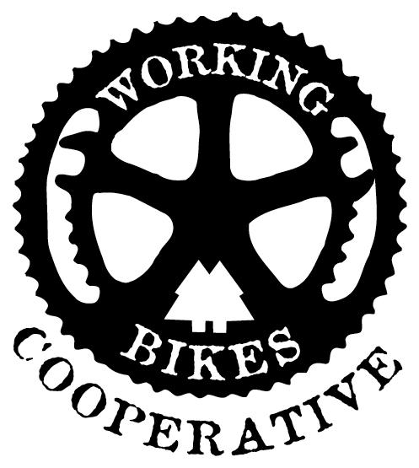

Every year in the United States millions of bicycles are discarded or sit unused in basements or garages.
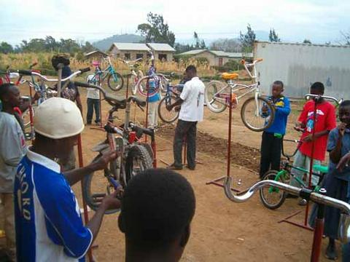
Bicycle repair instruction in Tanzania

But in a developing country a bicycle can make all the difference between work and unemployment. Bikes in a developing country are used for transportation, cargo, and even emergency vehicles. Teachers use bikes to reach distant classrooms while farmers use bikes to transport crops to market.

